

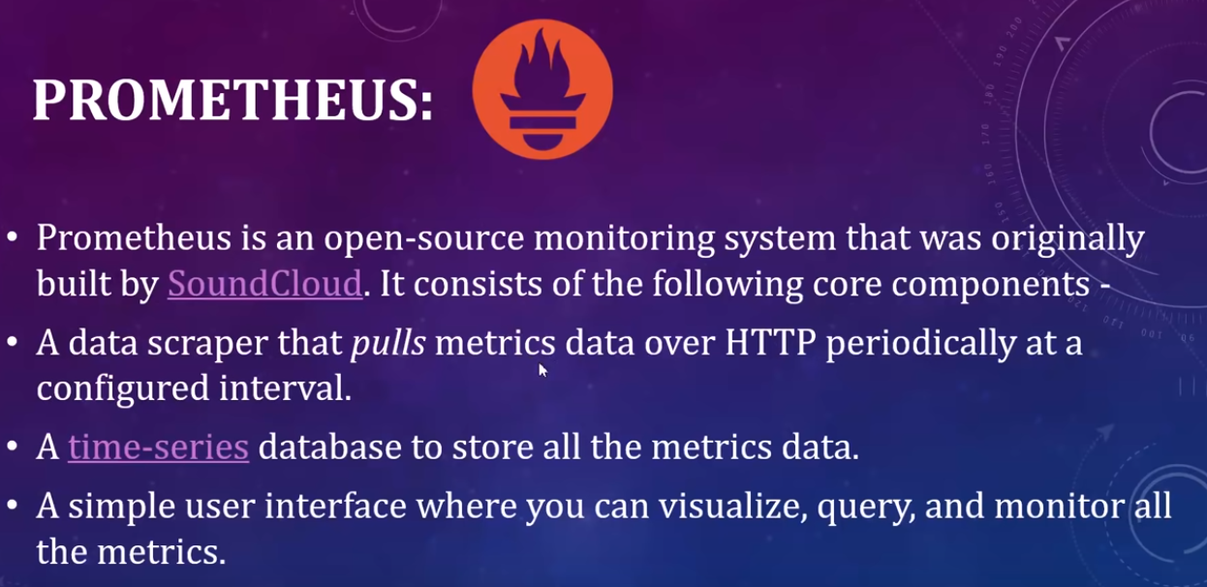

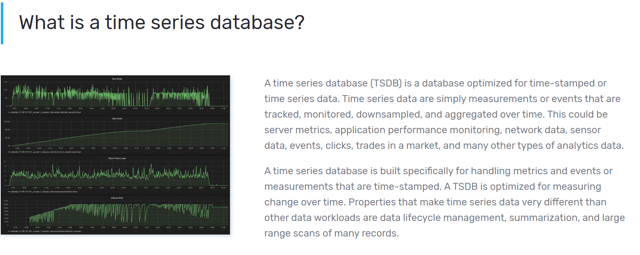

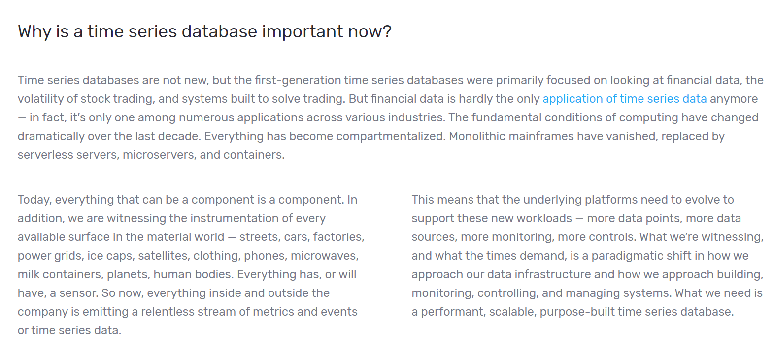

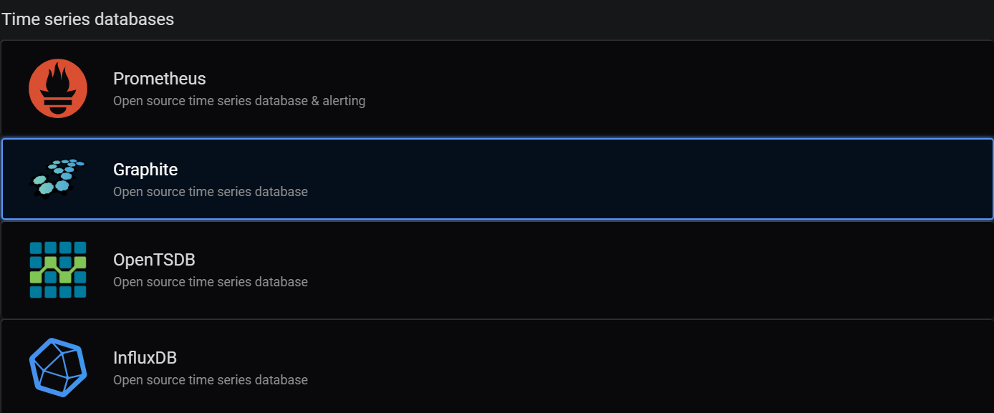



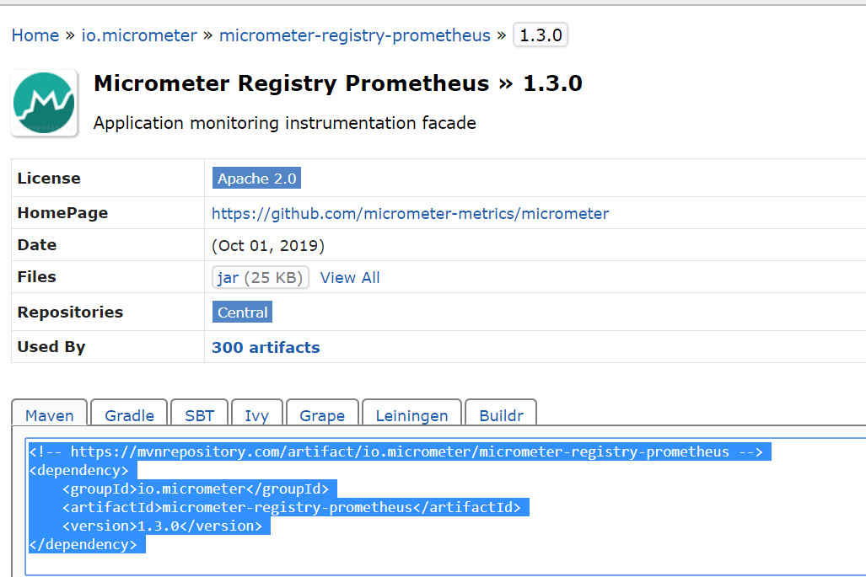

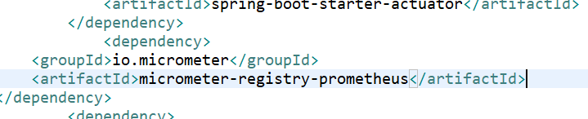

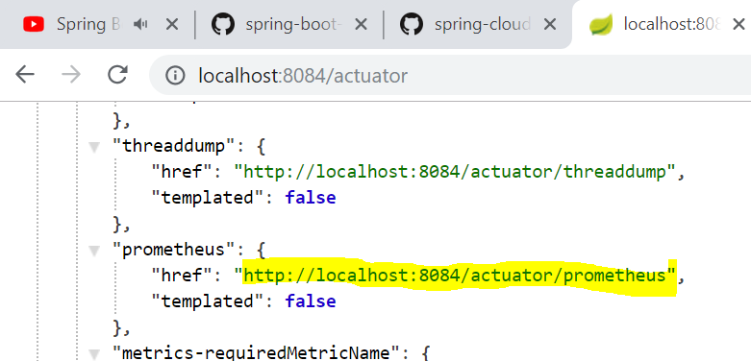

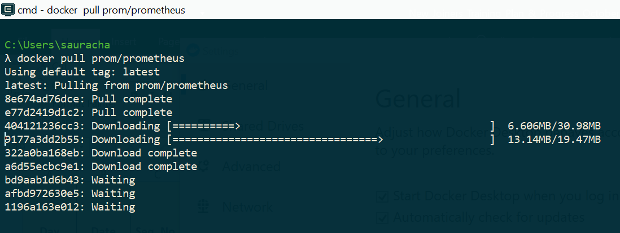

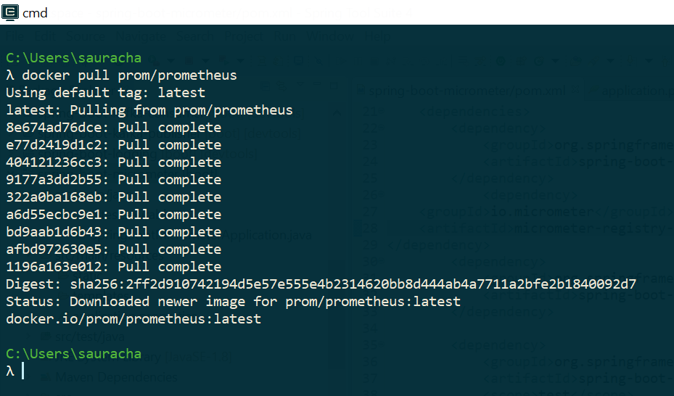

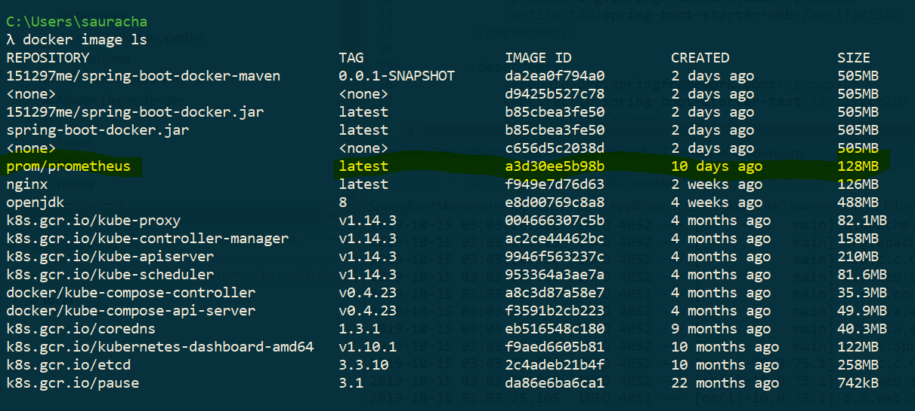

**Command to Run Prometheus Server using configuration from Prometheus.yml file as BELOW :**

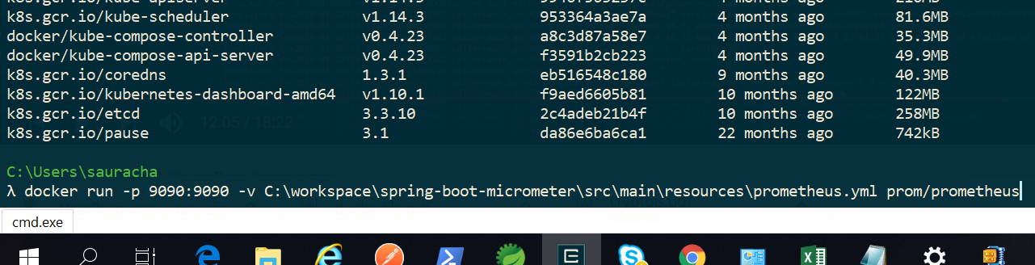

**Prometheus Server Ready to receive Requests !!**

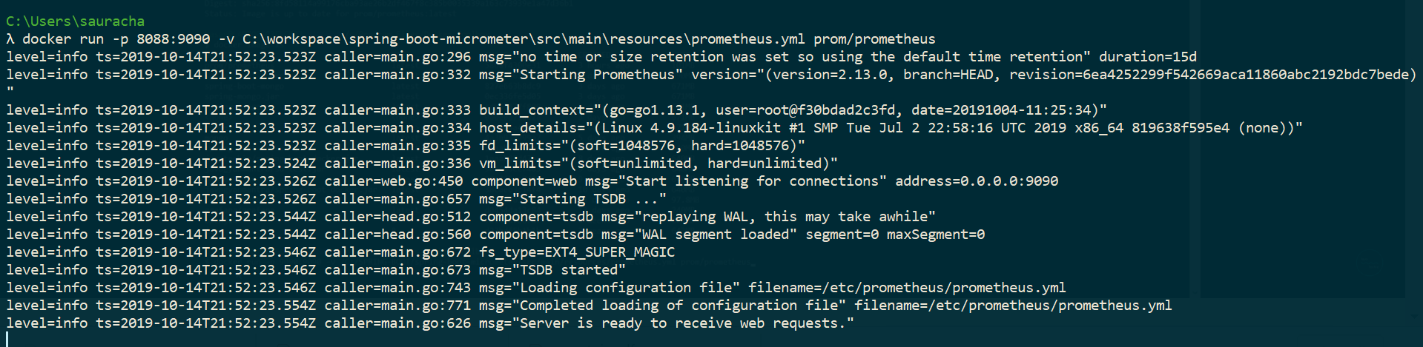

**Prometheus UP on my local !!!**

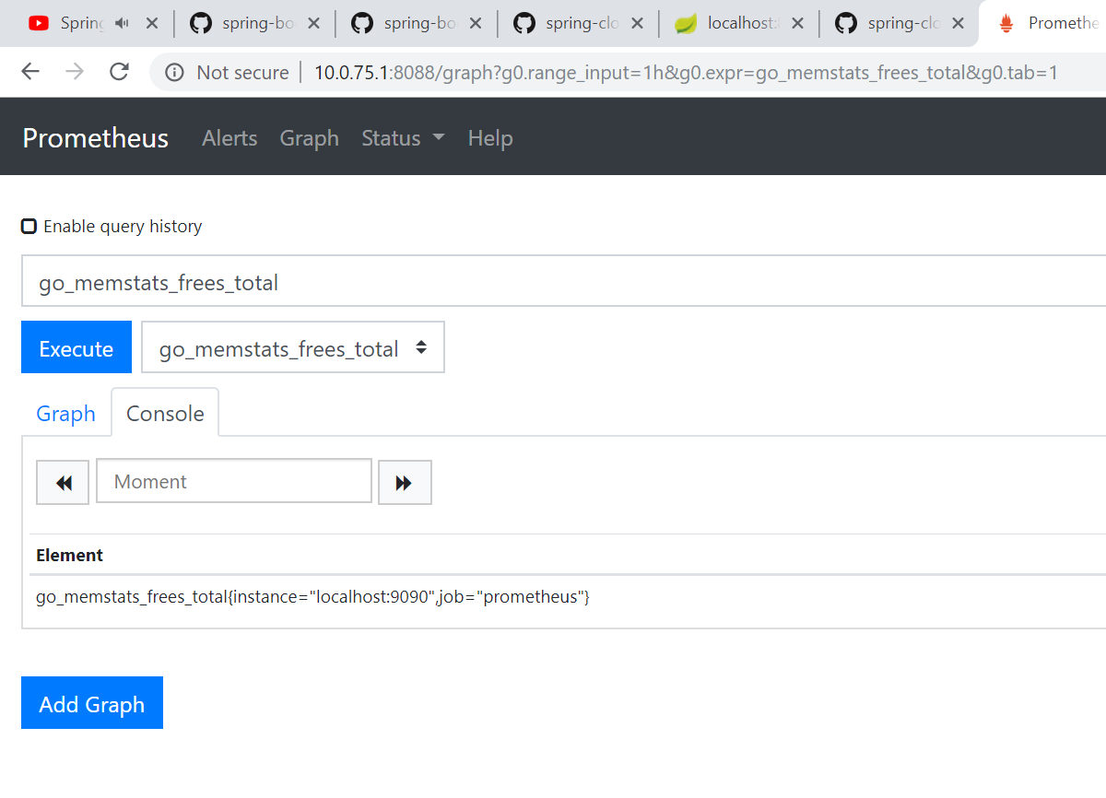

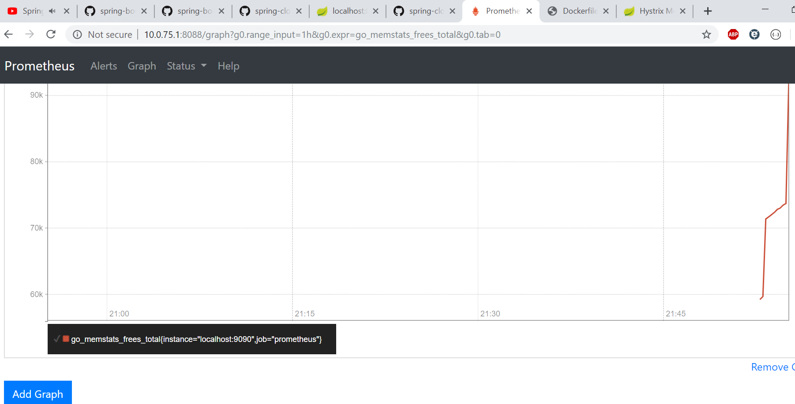

**This is how we represented graph of our actuator metrics for Prometheus !!!!**

**Now from Prometheus we will fetch data and show into GRAFANA !!!**

**Command to Pull & Run Grafana Image ========🡺**

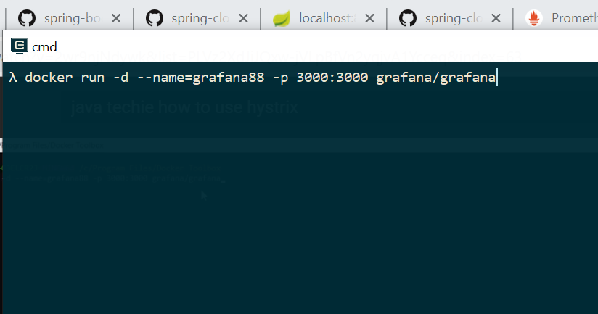

**Grafana Image being downloaded …**

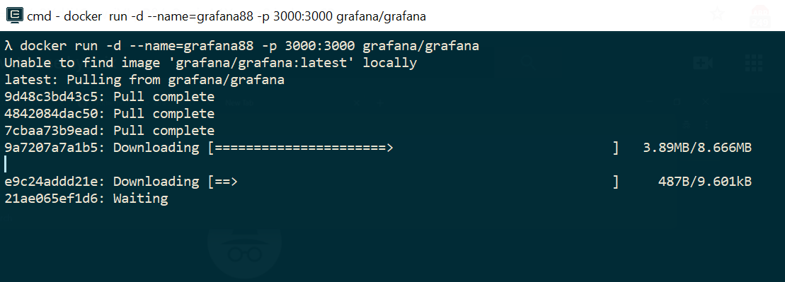

**Grafana is up at** [**http://localhost:3000**](http://localhost:3000) **.**

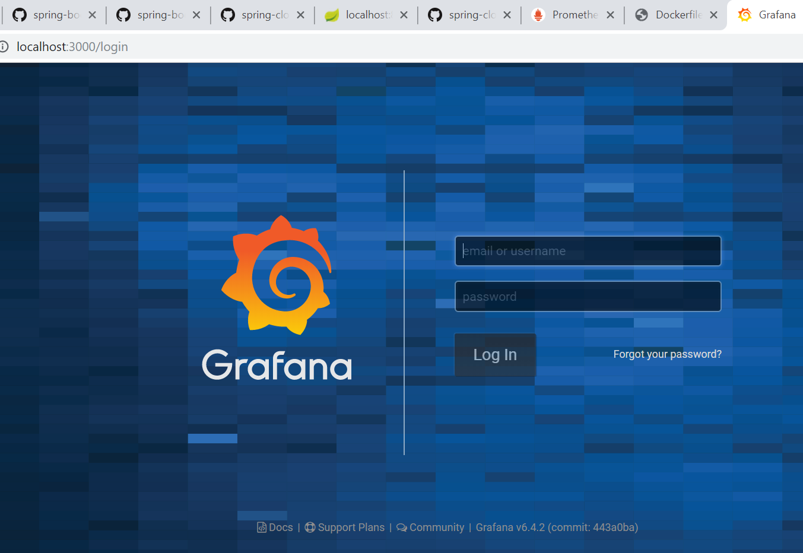

**Default Username and Password for Grafana =====🡺 Admin , Admin**

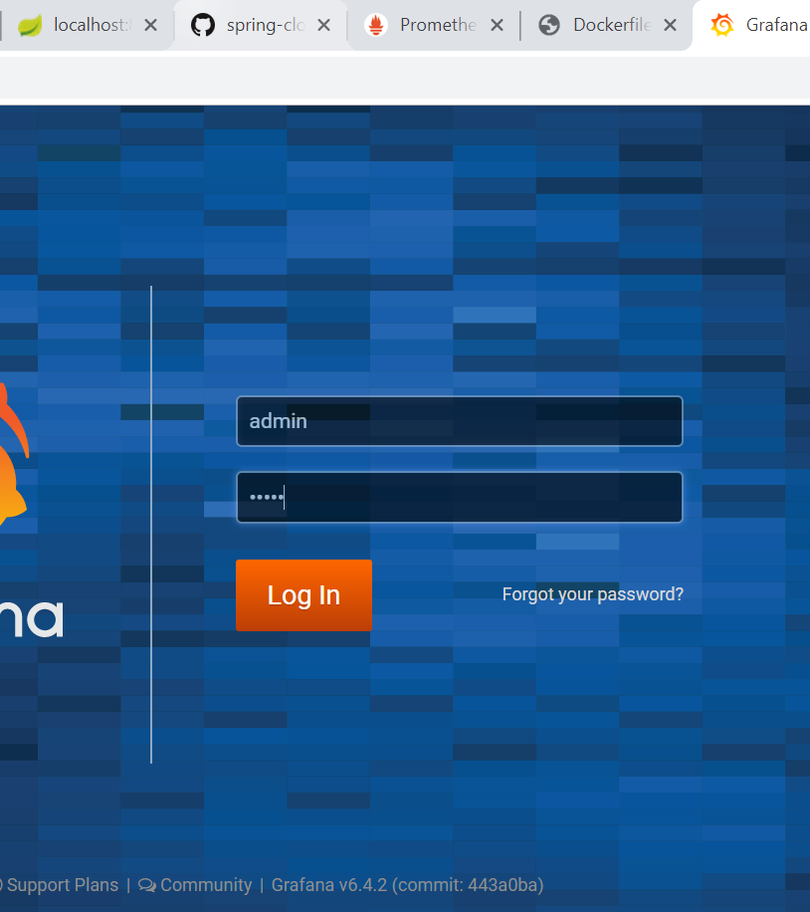

**Grafana Datasource Connection With Grafana is Working !!**

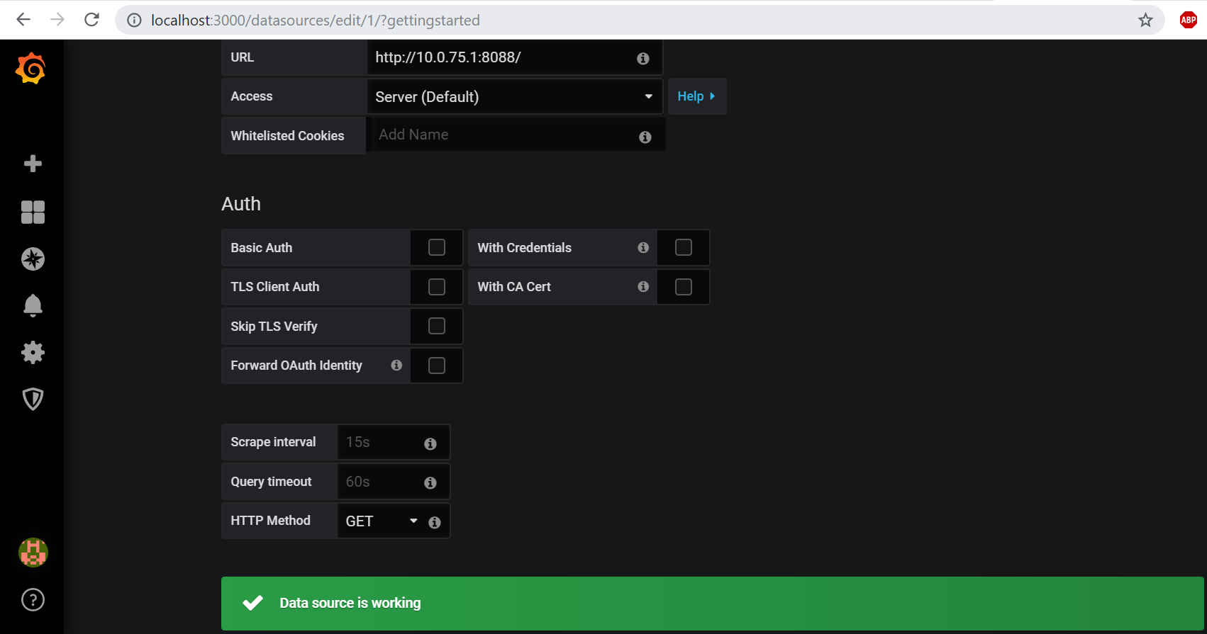

**Let’s copy a metric from Prometheus Screen which we want to Visualize on Grafana Graph based**

**Dashboard :**

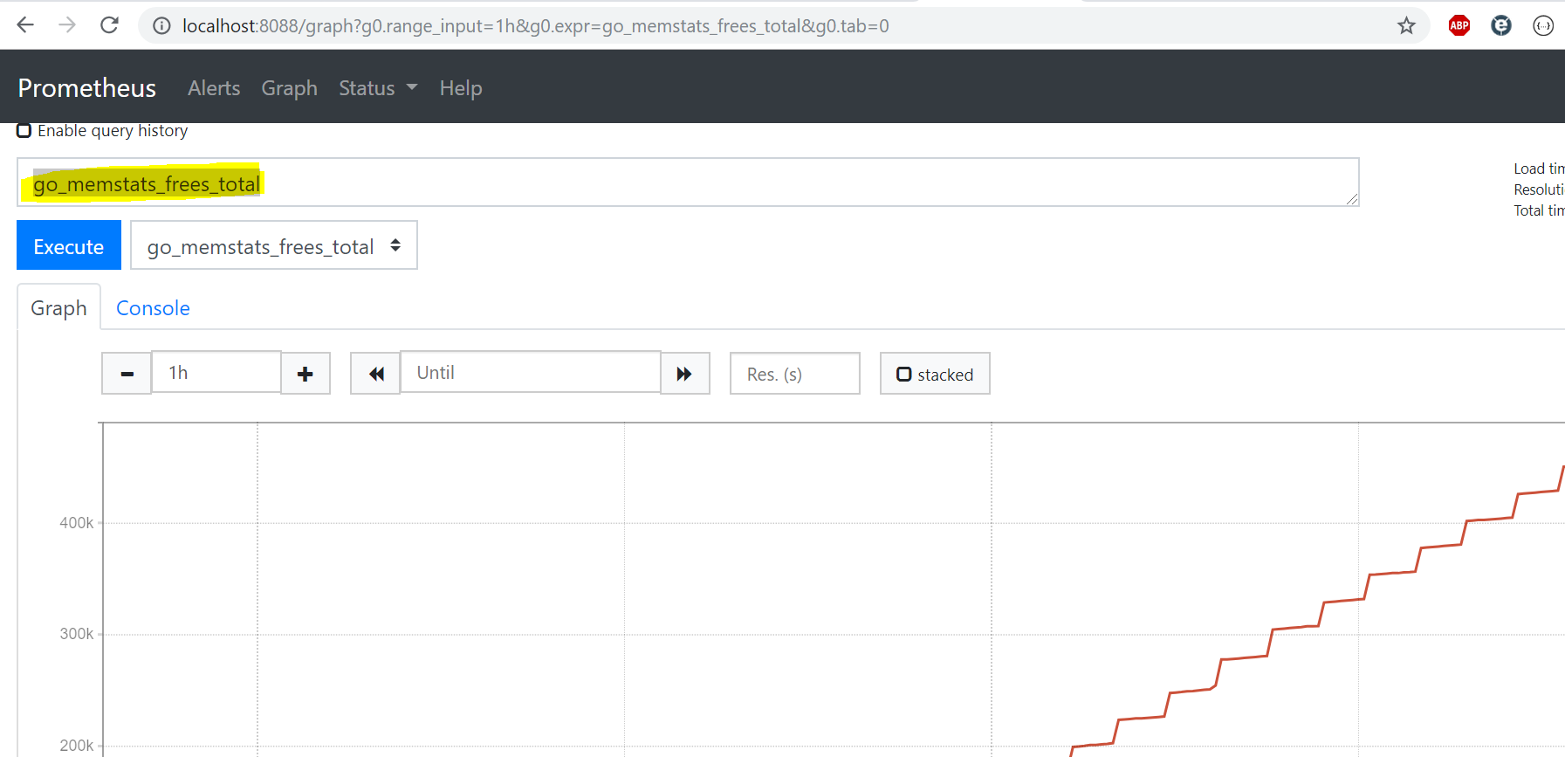

**We are able to see a graphical representation of the above metric in Grafana as below :**

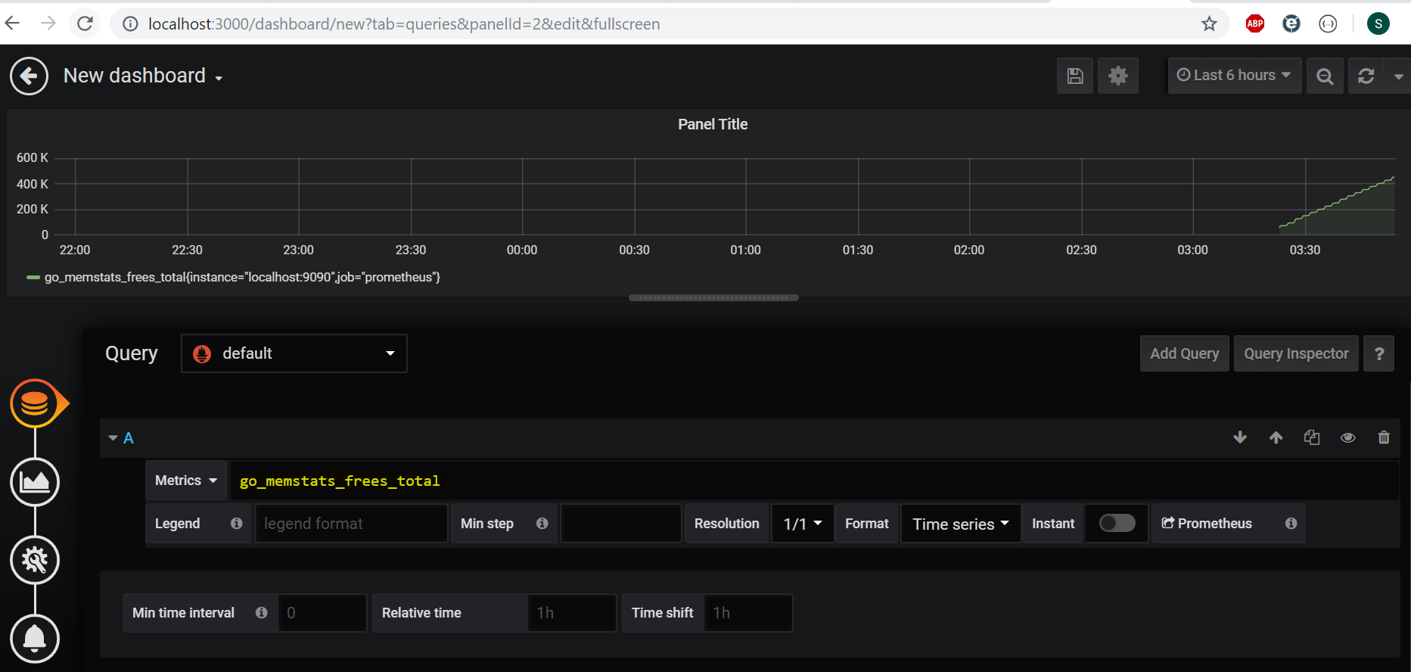

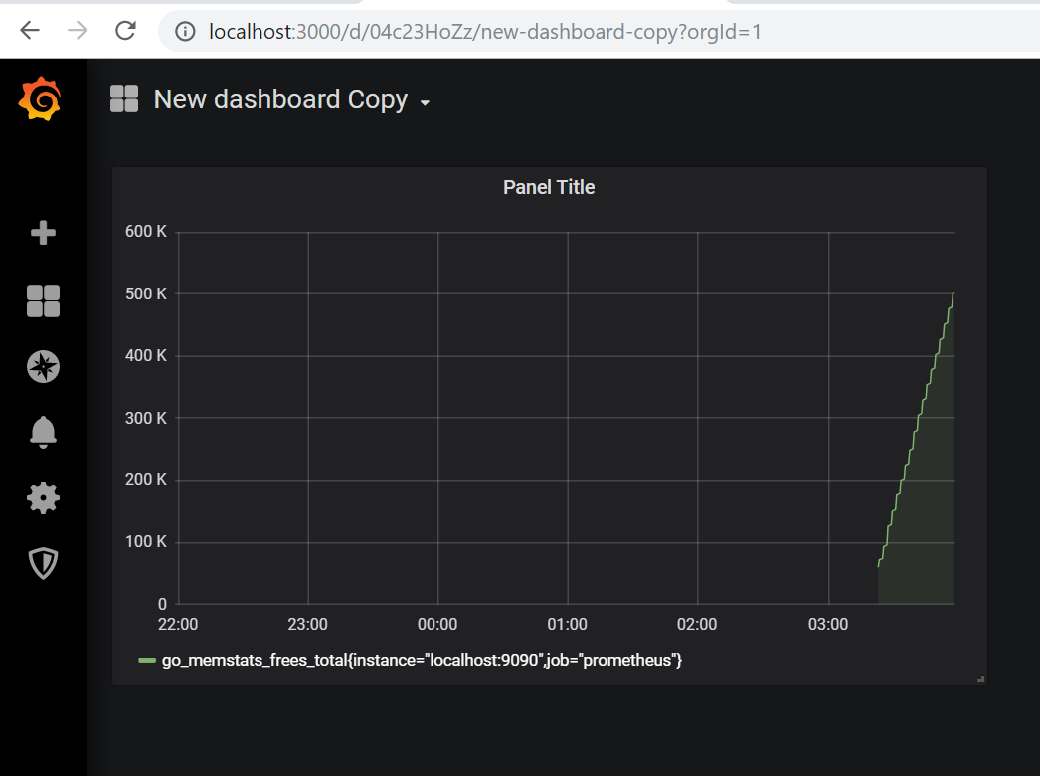

**Prometheus :** [**http://localhost:8088**](http://localhost:8088)

**Grafana : http://localhost:3000**